Utility to download Manual Test Cases
From Quality Center to Excel Sheet

Introduction

Currently we didn’t have any option in Quality Center from where we can download the manual test cases present in a particular folder into the excel sheet. We need to download each test case individually and export it to excel. And then again need to consolidate those into one sheet. This utility will help you to download manual test cases from a particular folder (and the subfolders) from Quality Center to a single excel sheet. This reduces the time as well as the manual effort of downloading test cases.

Configuration

Operating System – All Windows flavors.
Advantages

- Downloads the manual test cases from QC at any time.

- Saves the manual effort of opening each test case and saving them individually, hence saves lot of time.

Prerequisite
Open Excel and go to menu
Tools > Macro > Security
Macro security level should be set to Low.

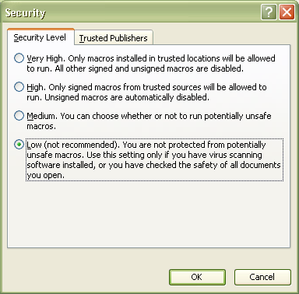

Process

1. Open the QC2Excel.xls sheet.

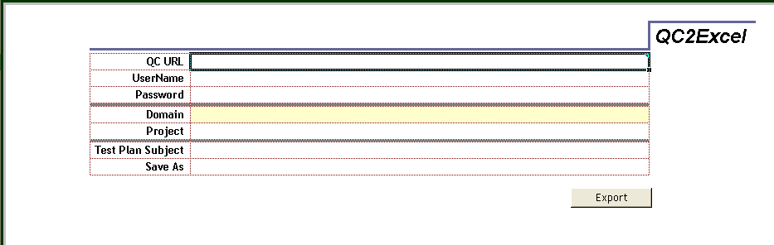

2. Provide the following parameter values in the sheet –

Parameter | Details
QC URL | URL of the Quality Center (e.g. //http:/<server>[:port]/qcbin)
UserName | Login name for Quality Center
Password | Password
Domain | Domain name
Project | Project Name
Test Plan Subject | Folder where manual test cases are present  (Put the Test Plan folder name as  Subject\...................  Example - Subject\Enterprise Release Participants\Enterprise Systems\Customer\CIS\ER310\Gap 3618 Index-Expand Alias Name)
Save as | Local path where you want to save the file (e.g. C:\temp\TestCases.xls)

3. Click on the Export button provided at the right corner of the table.

4. “Please wait…” message will be displayed while the process is in progress

5. All the test cases are downloaded into the excel sheet mention in the “Save As” parameter.

6. Excel sheet gets open.

Note: In case of any error while login into the Quality Center, appropriate error message will be displayed on the page.

